React JS

What are components
Components are building blocks of react application that represents a part of user interface

Ex: if we take above image
1.login credentials is one component
2.icon component
3.image component
4.signup component

Reusability
A component used in one area of the application can be reused in another area. This helps speed up the development process
Types of components:
1.stateless functional component:
They are Js functions, they return html, can be contained in a .js or .jsx file
2.statefull class components:
Regular classes that extends the component class, they must contain render method, they return html, can be contained in .js or .jsx file
Nesting Components: Components have to be nested in main component using import and export keyword
1.export: feature is used to export particular module(file) and use it in another module(file).
2.import: this feature is used to import particular module(file) and use it in existing module.

Export:
Export default class comp extends react. Component
Default export: we can give alias name while importing from another module
Ex: import functionalcomp from “./components/functionalcomp”
Import Fc from “./components/functionalcomp”

Named export and import:
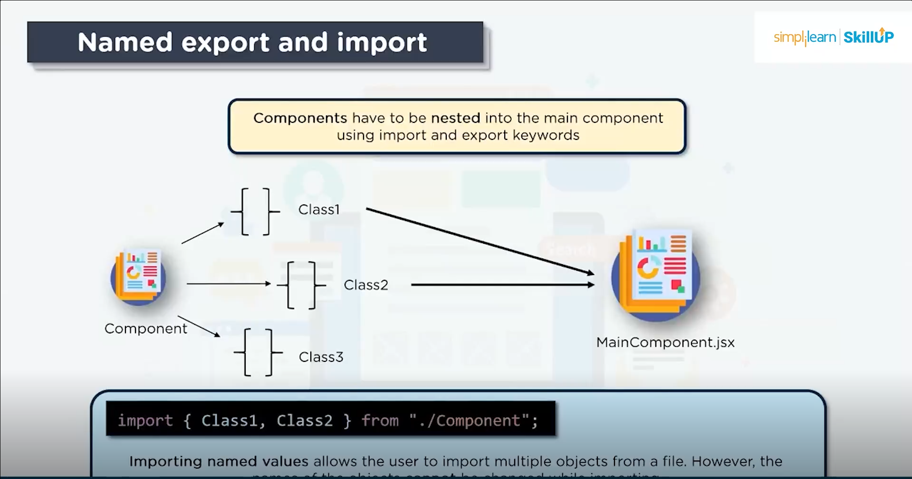
Ex: import {class1, class2} from “./component”

Higher-order-component:

Pure-component:

